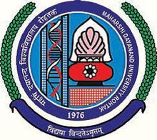
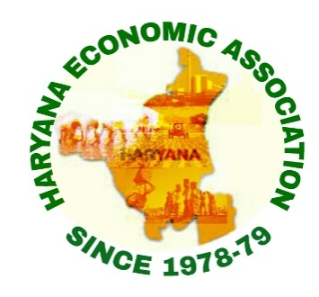

INTERNATIONAL CONFERENCE
On
ECONOMICS AND DEVELOPMENT
NEW CHALLENGES AND OPPORTUNITIES
March 11-12, 2019

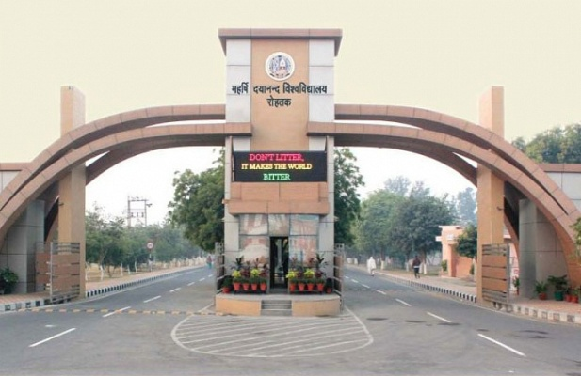

Jointly Organized by
Haryana Economic Association (HEA)
&
Department of Economics
MaharshiDayanand University, Rohtak
Haryana, India
(NAAC Accredited ‘A’ Grade University)

About the University
MaharshiDayanadUniversity is one of the Premier Universities of the State of Haryana which was established by an Act. 25 of 1975 of the Haryana Legislative Assembly in 1976 with the objectives to promote interdisciplinary research in Social Sciences and other prominent disciplines of sciences. The university secured the recognition of UGC for Central Grants in 1979.
The University is located in Rohtak which is one of the most beautiful city of Haryana which is situated in the Delhi-NCR region and it is well connected with the National highways and railways.It lies 70 kilometres (43 mi) North West of New Delhi and 250 kilometres (160 mi) South of the State capital Chandigarh on NH 9(old NH 10). The campus of the University is well known for its beautifulness, State-of-the-art buildings and spectacle green area. The University has been Ranked First amongst the cleanest Higher Education Institutions in the Country in the Category of Government Universities.
The University is offering different educational and research programmes through 38 well equipped Departments. Apart from this, University has two majestic auditoriums i.e. Tagore Auditorium and Radha Krishnan Auditorium equipped with modern amenities, Health Centre, Faculty House, Sports Stadium, Multi-purpose Gymnasium Hall, Faculty Club etc.
About the Department
The Department of Economics is one of the oldest Department of the University which was established in 1970 as a regional Centre of the Panjab University, Chandigarh. Later in 1974, the Department was affiliated with the Kurukshetra University, Kurukshetra and in 1976, this Department became the part of M.D. University, Rohtak. The Department is offering large number of programmes like Masters in Economics, M.A. Five Years’IntegratedProgramme, M.Phil. and Ph.D.
About the Haryana Economic Association

Haryana economic association was formed in 1979 to promote teaching and research in economic theory in relation to the economic science in general and economy of Haryana in particular. To promote these objectives, the association will be undertaking following activities.
- To hold conferences
- To undertake and promote research projects and studies.
- To bring out a journal
- To publish books, periodicals and brochures etc.
- To organize lecture, debate, discussion, workshops and seminars etc.
- To accept grants, donations, gifts, fees and subscriptions.
About the conference
The organising committee on the behalf of department of economics invite you to participate in the international conference on “Economics and Development: New Challenges and Opportunities” in collaboration with Haryana Economic Association. This collaboration would raise the academic standard of conference and will go a long way in strengthening and raising the academic standard of the scholars and teachers.
Sub themes of the conferences:
- Role of organised and unorganised sector in economic development
- Issues of poverty, unemployment, inequality, social exclusion and gender.
- Banking sector distress and policy intervention.
- Farm and non-farm sector distress and policy intervention.
- Role of health and education in economic development.
- Social environment and sustainable growth.
- Jobless growth: myth or hype.
- Fourth industrial revolution.
- Emerging issues in world economy.
Paper submission:
The authors are requested to submit their research papers as per following schedule:
- Last date of Submission of paper (soft copy): March 4, 2019
- Communication of Acceptance March 6, 2019
The paper must be sent through email: heaecoconference2019@gmail.com
Registration
The registration feefor the participants is Rs. 1000/- (for Teachers/Professionals/who are not life members of HEA) and Rs.750/- (for life members of HEA/Scholars/PG students). The registration fee of outside participants will be received in Cash on spot. All Local participants may deposit their registration fee up toMarch 07, 2019.
Boarding and Lodging
The Boarding and Lodging will be provided only to the outside registered participants. The participants are requested to intimate the organizers for requirement of accommodation upto March 7, 2019 positively. Any Request for on spot accommodation will not be considered.

Patron-in-Chief: Prof.Rajbir Singh, Hon’ble Vice-Chancellor, M.D. University, Rohtak
Patrons:
Prof. Anita Dagar, Head, Department of Economics, M.D. University, Rohtak
Prof.KavitaChakravarty, Department of Economics, M.D. University, Rohtak
Convener:
Prof.NeelamChoudhary, Department of Economics, M.D. University, Rohtak.
Organizing Secretary:
Dr. Jagdeep Dahiya
Assistant Professor Stage II
Department of Economics
M.D. University, Rohtak
Mobile: 9050177706

Organizing Committee:
Dr. Rajesh Kumar
Dr.BimlaLangyan
Ms.KiranBala
Ms.AkshuHooda
Ms.VineetaKaushik

Advisory Committee
Prof. Santosh Nandal, Department of Economics, M.D. University, Rohtak
Dr. Manoj Siwach, President, Haryana Economic Association (HEA).
Dr.Himmat Singh Ratnoo, Associate Professor, M.D. University, Rohtak.
Prof.Radhika Desai, Director, Geopolitical Economic Research, University of Manitoba, Winnipeg, Canada.
Dr.Pritam Singh, Prof. of Economics, Oxford Brookes University, Oxford, UK.
Prof. Ram Singh, Delhi School of Economics, University of Delhi.
Prof.Supriya Singh, RMIT University, Melbourne, Australia.
Prof. D.K. Naurial, Vice-Chancellor, Kumaun University, Nanital, UK
Prof.Rajvir Singh, Former member, Commission for Agricultural cost and Prices, Govt. Of India.
Prof.Ramana Murthy, Department of Economics, Central University of Hyderabad.
Prof.(Retd.) S.D. Chamola, Patron Haryana Economic Association.
Prof. S.P. Singh, Department of Humanities and Social Sciences, IIT Roorkee.
Prof.Sharanjeet Singh Dhillon, Former Registrar, Guru Nanak Dev University, Amritsar, Punjab.

Contact Details
Dr. Jagdeep Dahiya  Organising Secretary  Department of Economics,  MDU, Rohtak  Mobile: 9050177706  Email: jagdeepdhy@gmail.com | Dr. Manoj Siwach,  President, Haryana Economic Association (HEA).  Mobile: 9416060577, 8708716186  Email: manojsiwach70@gmail.com

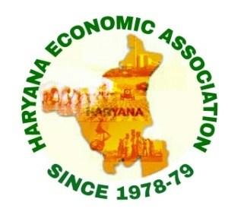
INTERNATIONAL CONFERENCE
ON
ECONOMICS AND DEVELOPMENT: NEW CHALLENGES AND OPPORTUNITIES
(March 11-12, 2019)
REGISTRATION FORM

Name (Prof./Dr./Mr./Ms.): ………………………………………………………
Designation : ………………………………………………………
Organisation/Affiliation : ………………………………………………………
Postal Address : ………………………………………………………
Phone /Mobile number : ………………………………………………………
Email : ………………………………………………………
Title of Research Paper : ………………………...…………………………….
...………………………………………………...........
Registration fee : ………………………………………………………
Accommodation :………………………………………………………………..
Note: if accommodation is required please inform up to 07.03.2019.
Declaration: I/we hereby declare that the content of the manuscript is my/our original work carried out by me/us and free from plagiarism. I/we will be solely responsible for its plagiarism. This paper has neither been published earlier nor submitted for publication in any Conference/Seminar/Symposium.

Place
Date Signature

