TABLE OF CONTENTS

Sr. No. | Name of Contents
 | INVITATION FOR BIDS
i | Press Notice
ii | Detailed Notice Inviting Tender
iii | Instructions to bidder on Electronic Tendering System
A | Scope of Work
B | Eligibility Criteria
C | General Terms & Conditions
D | Appendix – I, Annexure – I, II & III
E | Check List of Technical Document

PRESS NOTICE

M.D.University, Rohtak
Notice Inviting Tender

Name of Work : Providing the services of Secretarial Staff for offices, Laboratories, Library etc. in the University.
Cost : Rs. 20.00 Crores (approximately)
Earnest Money : Rs. 40.00 Lacs
Time Limit : 2 years
Tenders to be received till : 3:00 P.M. on dated 26.11.2019
- The tenders will be received only through E-tendering for further details visit website http://www.etenders.hry.nic.in
- Cost of Bid document is Rs. 50,000 (non refundable), e-Service fees is Rs. 1000/- (non refundable) and Earnest Money as stated above will be deposited through online NETBANKING/NEFT/RTGS.
- The Contractors/agencies will keep in touch with the Website (http://www.etenders.hry.nic.in) for any amendment/addendum till the last date/revised last date of submission of tender and may incorporate such changes in the tender bids, if required.

Registrar
M.D.University, Rohtak

DETAIL NOTICE INVITING TENDER

e-Tender is invited for purchase/work/service of below mentioned items in single stage two cover system i.e. Request for Pre-Qualification/Technical Bid (online Bid under PQQ/ Technical Envelope) and Request for Financial Bid (comprising of price bid Proposal under online available Commercial Envelope):-
Sr. No | Description of work / Items | Appx. Cost (Rs. In lacs) | EMD to be deposited  by Bidder | Tender Document Fee (Rs.) and e-service/ processing fee | Start Date & Time of Bid Preparation & Submission | Expiry Date & Time of Bid Preparation & Submission
1. | Providing the services of Secretarial Staff for offices, Laboratories., Library etc in M.D.University, Rohtak | Rs. 20.00 Crore | Rs. 40.00/- Lacs | Rs. 50,000/-for Tender Document fee and Rs.1000/-for e-service/ processing fee | 30/10/2019 | 26/11/2019  3:00 P.M.
1. Detailed notice inviting tender/estimate drawing can be seen in the office of the undersigned during office hours.
2. Bidding documents available on website http://www.etenders.hry.nic.in
3. Newly enlisted contractors/societies/suppliers/manufactures should bring with them proof of their enlistment in appropriate class.
4. The bidders would submit bid through e-tendering only on the website i.e. http://www.etenders.hry.nic.in
Under this process, the Pre-qualification/ Technical online bid Application as well as online Price Bid shall be invited at single stage under two covers i.e. PQQ/Technical & Commercial Envelope. Eligibility and qualification of the Applicant will be first examined based on the details submitted online under first cover (PQQ or Technical) with respect to eligibility and qualification criteria prescribed in this Tender document. The Price Bid under the second cover shall be opened for only those Applicants whose PQQ/ Technical Applications are responsive to eligibility and qualifications requirements as per Tender document.
- The payment for Tender Document Fee shall be made by eligible bidders, e-Service/Processing fees and Earnest Money as stated above will be deposited through online NETBANKING/NEFT/RTGS.
- Intending bidders will be mandatorily required to online sign-up (create user account) on the website http://www.etenders.hry.nic.in to be eligible to participate in the e-Tender. He/She will be required to make online payment of (as mentioned above) towards EMD fee in due course of time. The intended bidder fails to pay EMD fee under the stipulated time frame shall not be allow to submit his / her bids for the respective event / Tenders.
- The interested bidders must remit the funds at least T+1 working day (Transaction day + One working Day) in advance i.e. on or before (as mentioned above); and make payment through online. The intended bidder / Agency thereafter will be able to successfully verify their payment online, and submit their bids on or before the expiry date & time of the respective events/Tenders at http://www.etenders.hry.nic.in .

The Bidders can submit their tender documents (Online) as per the dates mentioned in the key dates:-
Key Dates
Sr. No. | Department Stage | Bidder's Stage | Start date and time | Expiry date and time
1 |  | Tender Document Download and Bid Preparation/Submission | 30/10/2019 | 26/11/2019
2 | Technical Bid Opening |  | 28/11/2019 at 3:00 P.M.
3 | Financial Bid Opening |  | To be decided after opening of Technical Bid
* Hard copy of the Technical Documents may be submitted in the office of the Assistant Registrar (Estt.N.T) M.D.University, Rohtak before the Technical Bid Opening.
Important Note:
- The Applicants/bidders have to complete ‘Application / Bid Preparation & Submission’ stage on scheduled time as mentioned above. If any Applicant / bidder failed to complete his / her aforesaid stage in the stipulated online time schedule for this stage, his / her Application/bid status will be considered as ‘Applications / bids not submitted’.
- Applicant/Bidder must confirm & check his/her Application/bid status after completion of his/her all activities for e-bidding.
- Applicant/Bidder can rework on his/her bids even after completion of ‘Application/Bid Preparation & submission stage’ (Application/Bidder Stage), subject to the condition that the rework must take place during the stipulated time frame of the Applicant/Bidder Stage.
- In the first instance, the online payment details of tender document fee + e-Service and EMD & PQQ/Technical Envelope shall be opened. Henceforth financial bid quoted against each of the item by the shortlisted bidder/ Agency wherever required shall be opened online in the presence of such bidders/ Agency who either themselves or through their representatives choose to be present. The bidder can submit online their bids as per the dates mentioned in the schedule/Key Dates above.
The bids shall be submitted online in two separate envelopes:
Envelope 1: Technical Bid
The bidders shall upload the required eligibility & technical documents online in the Technical Bid.
Envelope 2: Commercial Bid
The bidders shall quote the prices in price bid format under Commercial Bid.

(A) SCOPE OF WORK :
- Total Manpower Requirement : The total approximate requirement of manpower to be deployed by the agency on each working day for different services/activities as under :-
Clerk | 90
Data Entry Operator | 3
Steno-Typist | 3
Labour, Peon, Multi Tasking Staff | 151
Library Attendant | 21
Laboratory Attendant | 31
Waiter/Helper | 14
Computer Operator | 1
Computer Operator | 1
Technical Assistant | 10
Junior Store Keeper | 1
Hardware Supervisor | 1
Laboratory Supervisor | 1
Mess Supervisor | 11
Lady Aya | 19
Laboratory Assistant | 2
Day Care Incharge | 1
Multi Purpose Health Worker | 1
Dispensary Attendant | 1
Lift Attendant | 2
Driver | 3
Laboratory Boy | 2
Engineer | 1
Mechanic | 1
Receptionist | 1
Laboratory Technician | 4
Steward | 3
Coach | 8
Assistant | 3
Section Officer | 1
Assistant Registrar | 3
Clerk | 3
Draftsman | 1
Instructor | 7
Superintendent | 1
Dishwasher | 1
Field Organizer | 1
DTP Operator | 1
Technical Labour(press) | 6
Network Helper | 02
Junior Programmer | 04
Deputy Registrar | 01

- The physically fit persons having the prescribed qualifications for each service/activities by the university shall be provided. The university shall be at liberty (a) not to accept any individual (b) return/relieve already accepted individual provided by the agency, without assigning any reason.
- The manpower may be increased/decreased as per requirement as approved by the University authorities from time to time & payment will be made accordingly.
- The agency appointed for providing above services shall enter into a binding agreement/MoU with the University for the Execution of services wherein all the obligations of both the parties shall be spelt out.
(B) ELIGIBILITY CONDITIONS :
1. The agency must have an experience of atleast five years for providing the services of Secretarial Staff/manpower supply for offices, facility management etc. and must therefore, attach a certificate of experience.
2. The agency should have provided the services of Secretarial Staff/manpower supply for offices in Govt. Departments/PSU/ Govt. Universities as follows:
- One work of more than 40% of the estimated cost in last seven financial years upto year ending 2018-19.
OR
- Two works of more than 33.3% of the estimated cost in last five financial years upto year ending 2018-19.
OR
- Three works of more than 25% of the estimated cost in last three financial years upto year ending 2018-19.
- The agency should have completed at least one work of contract amount Rs. 2.00 crore in a year for providing the services of Secretarial Staff/manpower supply for offices in Govt. Universities /Govt. Institutions.
- The agency with an average annual turnover of less than 30% of estimated cost for last three financial years upto ending 2018-19 from similar business will not be entertained. Proof of turnover duly certified by the Auditor shall be attached with the bid.
- Pre-bid meeting will be held on 08-11-2019 at 10:00 A.M and all interested agencies may attend.
- Bank Solvency certificate to be submitted for the value of Rs. 2.00 crores which should have been issued by the Bank within one year from the date of publication of this NIT.
- Copy of Registration Certificate of the firm under Companies Act/Partnership Act, if any.
- Copy of PAN NO, GST NO.
- The agency must be registered with ESI, EPF. The proof of depositing of EPF & ESI challans of at least 250 persons (at present) should be submitted by the agency.
- List of clients (central/state Govt. Dept. / University / PSU / Private Organizations etc) along with complete addresses and telephone numbers and satisfactory service certificate.
- Income tax return of last 3 financial years.
- The firm should be ISO-9000 certified.
- The agency should submit a certificate of non-debarment/non blacklisting from any department. An undertaking in this regard should be submitted by the agency.
- In case any family member of the agency is serving in the University then the agency must record a certificate to that effect on the offer failing which the quotation/ tender shall be rejected out-rightly.
- The agency shall submit a copy of the registered partnership deed, if any, with the tender and the copy must be signed by all the partners.
- The tenderers may visit the offices in the University Campus before submission of tender for any query or may contact Assistant Registrar (Estt.N.T), MDU, Rohtak (Mob. 9466473732).
- The price bid will be opened only of those tenderers who qualify in the technical bid as laid down by the University as above.
- The tender must be valid for a period of at least three months from the date of its opening.
- Joint Venture is allowed as per Joint Venture Act. (Annexure – II & III)
(C) GENERAL TERMS AND CONDITIONS :
- Performance Security @ 5% (@6% in case of Joint Venture) of awarded cost in the shape of Bank Guarantee will be deposited by the agency within 21 days of the allotment of contract. This Performance Security will be refunded after three months of completion of contract. However, if the contract period is extended beyond 2 years, the Bank Guarantee will require to be extended accordingly by agency.
- Agencies will quote the rate of service charges with absolutely no hidden costs in any form or manner.
- Initially the contract will be awarded for a period of two years and can be extended/renewed on year-to-year basis for the next two years subject to mutual consent of both the parties, provided the services of the agency are found satisfactory.
- Tenders received after due date and time or incomplete are liable to be rejected out-rightly.
- The agency appointed for providing above services shall enter into a binding agreement/MoU with the University for the Execution of services wherein all the obligations of both the parties shall be spelt out.
- No interest will be paid on the Earnest Money and Performance Security by the University.
- Right of acceptance/rejection of any or all the tenders rests with the University without assigning any reason and the decision in all such matters shall be final and binding on all Tenderers.
- The mere fact of having quoted the lowest rates shall not vest in an agency any right to be considered for award of this contract. Other important considerations such as financial viability, experience, possession of trained, qualified and experienced manpower and administrative structure required for efficient execution of services, etc. shall also be taken into account while considering each bid. An agency submitting a bid which is considered as unrealistically low and/or financially unworkable in view of the existing policy/instructions of the State Govt. relating to minimum wages, without reasonable margin of contractor profit etc. shall be out-rightly rejected.
- The agency shall indemnify/compensate MDU and its properties for all losses/claims caused/ likely to be caused due to any omission /neglect /action, legal demand, proceedings, prosecutions, attachments, non payment of taxes, non-clearance of liabilities, non-observance of statutory law/rule of the local bodies/state/central government and the like arising due to agency’s or its workmen’s fault and/or on account of any deficiency on their part.
- Agency shall be responsible for safe custody and ability service of any equipment, machine, tools and stores provided by the University to its workmen for day-to-day use.
- The Agency shall have to submit an indemnity bond to indemnify the University with regard to damage done/caused to any property of the University and with regard to any litigation, whatsoever, involving the rights and welfare of the personnel engaged by it in connection with this contract.
- The workmen should have the qualifications as prescribed by the University for the said activity/service.
- The payment terms shall be as under:
  - The agency will be paid as per the amount calculated as follow :
DC rate + EPF(Employer Share on DC rate) + ESI (Employer Share on DC rate) + Labour Welfare Fund + PMC on DC rate as allotted + GST on gross amount. PMC charges will be quoted by the agency in the Financial Bid in the percentage(%).
  - The agency shall make the payment of remuneration to the workmen through Bank Transfer on the basis of prevailing DC Rates fixed by the Govt. of Haryana by 7th of every preceding month alongwith proof i.e. copy of ECR and Challan of depositing contribution of EPF and ESI in respect of each workman provided; and shall claim from the university by enclosing the necessary supporting documents/proofs by 15th of a month. In case the Agency does not make the payment by the 7th of every month a penalty of interest @ 10% p.a. may be imposed on the agency. This amount will not be reimbursed.
  - Payments of the bills shall be made to the agency as early as possible after submission of bills and subject to satisfactory execution of the work as certified by the Concerned HODs/Branch officers of the University alongwith absentee reports. The certificate shall invariably be recorded on the bill itself.
  - TDS towards Income Tax and any other statutory taxes/ceases/levies as applicable under govt. rules shall be deducted at source and deposited with the quarter concerned.
  - Agency should be financially capable for giving salaries to their employees and proper execution of work, for atleast 2 months in case payment delays from the University.
- The University shall not be responsible for payment of any claim whatsoever made by any individual engaged by the agency. The Agency will ensure all the standard safety precautions required for the job and ensure that its workmen are insured to cater for any mis-happening and/or injury sustained during discharge of duty in relation to this contract.
- The University shall not be liable for discharging any financial, judicial and/or administrative commitments made by the agency to any entity whatsoever in relation to this contract. In respect of quantum of wages, procedure of payment and protection of other statutory rights of employees, the agency shall adhere to the instructions of the Govt. to be received from time to time in letter and spirit including the following:
(i) The agency shall be solely responsible for fulfilling obligations towards its staff under various laws such as Minimum Wages Act, 1970 (Act 37 of 1970). Employee State Insurance Act 1948 (Act 34 of 1948). The Contractor/Agency shall be responsible for payment of wages of its staff (alongwith ESI, EPF, Maternity Benefits, etc.) at the rates notified by the Haryana Govt. under Minimum Wages Act from time to time. The Agency shall ensure the same and shall supply along with the bill monthly dossier in the format enclosed at Appendix - I to the University. The tender rates will be based on DC rates prevailing as on 01.03.2019. Thereafter tender rates for persons will be adjusted to the extent of 100% of the percentage increase of wages of the workman at revised DC rates applicable from time to time.
Rates will be rounded off to the nearest rupee. No other increase in tender rates will be permissible on any other account except for variation in amount of statutory taxes/levies on services mentioned in the DNIT, which will be payable /deductible on actual basis.
- The Agency shall make payments of wages to its employees through Bank Transfer and in case of default, the University may consider termination of contract.
- In case of termination of employment due to reduction in requirement of staff, such workers who lose employment should be considered for re-employment by the contractor when he redeploys or engages staff to meet increased requirement of manpower.
- The agency shall also follow the guidelines for compliance of Labour Laws received from Chief Secretary Govt. Letter No. 43/5/2001-3GS-II dated 20.02.2014.(Annexure-I) and further revised from time to time.
- The University shall have further right to impose penalty, adjust or deduct any of the amount on account of damages or losses including loss of reputation caused to the University due to any act of omission or negligence by the contractor or his workers/employees from his running bills and/or his security deposit. The Registrar, M.D. University, Rohtak shall be the sole authority to decide the penalty in each such case.
- The required trained Manpower not employed as per terms of the contract:-
Penalty:
Registrar will assess the deficiency in service and the cost saved by the contractor. The penalty shall be equal to the cost so saved plus 20% on each occurrence.
- Service not provided properly:
Penalty:
- Say a given job is not carried out properly or there is a complaint of rude behaviour by workmen engaged, etc. in such eventuality, the Registrar may impose a penalty on the agency @ Rs. 5000/- for each such occurrence and intimate the agency in writing immediately each time. Copy of all such letters shall be endorsed to the Finance Officer, and
- In addition, the cost incurred by MDU in securing the deficient service to its satisfaction, if any.
- A register will be maintained in the office of the agency showing record of manpower deployed on each day at different Depts/Branches.
- Terms and conditions printed on invoice of the agency if any shall not be binding on the University. Acceptance of the work order shall be construed as the agency’s complete agreement to all the terms and conditions contained in the agreement to be signed by both the parties.
- Any dispute arising with regard to any aspect of the contract shall be settled through mutual consultations and agreement between the contractor and the University. In case settlement is not arrived at, the dispute(s) will come under the purview of Indian Arbitration Act and the area of jurisdiction shall be at Rohtak. The arbitrator shall be appointed by the Vice-Chancellor.
- The successful tenderer/contractor shall not engage overtly or covertly any sub-contractor or transfer the contract to any other person/firm either wholly or in part.
- Amendment to the agreement:
The obligations of agency and of MDU will be spelt out in the agreement. However, during the operation of the agreement, circumstances may arise which may call for amendment or modification in the terms and conditions of the agreement. In such a situation, the amendments/modifications as may be mutually agreed upon shall be incorporated in the agreement accordingly.
- Doubts/Ambiguities:
If any doubt or ambiguity arises as to the meaning and/or effect of any provision(s) of the agreement, the same shall be referred to the Vice-Chancellor for clarification and his decision thereon shall be final and binding on both parties.
- All instructions/directions of the Controlling Officer and compliance reports thereof by the agency shall be in writing. There shall be no verbal communication in these matters.
- Whenever there is duplication in any clause either in the terms and conditions of this tender or in those of the Agreement, the clause which is considered more beneficial to MDU, Rohtak will be taken to be final.
- If the performance of the agency is not found to be satisfactory at any time during the contract period, the University shall be at liberty to terminate the contract without any liability on its part by giving one month’s notice.
- The agency shall attach the details of salary given for the previous month of all workers engaged by it along with the proof of ESI/EPF etc. deposited and other details as per the directions of Assistant Registrar (Estt.N.T) & as per the Labour Laws as follows:-
i) The agency must obtain labour licence which will be valid from Jan to Dec. and after that the agency must get the licence renewed from labour department accordingly.
ii) The agency is responsible for payment of wages of the workmen through bank transfer and the same must be credited into their bank accounts before 7th of every month as specified in the payment of Wages Act 1936 without any illegal deduction at all.
iii) The agency must maintain record of wages, leave and overtime, etc. not only for compliance of the wages law but as a proof which can be audited by the University before releasing the payment.
iv) The agency must be registered with EPF, ESI and Haryana Labour Welfare Board and take a proper code number, registration number and the copies thereof may be retained for record.
v) The agency must deposit the amount of EPF, ESI thereby submitting the list of workers in whose account it has to be deposited. The agency should also submit the Electronic Challan cum receipt (ECR) with full detail of individual worker regarding deposit of EPF in their account every month for record and verification. This is in addition to the copy of the half yearly return in Form No. 3A and annual return in Form No. 6A of Provident Fund Act. The agency must provide the statement of deposits to the workers regularly.
vi) It will be ensured that the EPF and ESI is to be deducted from the employee and employer strictly as per the labour law. Similarly the labour welfare contribution from the employee and from the employer must be deducted and deposited with the appropriate authorities as per latest labour laws.
vii) A certificate to this effect will be submitted by the agency upto 9th of every month.
viii) The Labour Law should also be followed strictly as amended from time to time by the Govt.
CHECK LIST OF TECHNICAL DOCUMENT

Sr. No. | Description | Bidders Response (Yes/No) and attached all documents while apply online bid
1 | The agency must have an experience of at least five years for providing the similar services and must therefore, attach a certificate of experience.
2 | The agency should have provided the services of Secretarial Staff/manpower supply for offices in Govt. Departments/PSU/ Govt. Universities as follows:  - One work of more than 40% of the estimated cost in last seven financial years upto year ending 2018-19.  OR  - Two works of more than 33.3% of the estimated cost in last five financial years upto year ending 2018-19.  OR  - c)Three works of more than 25% of the estimated cost in last three financial years upto year ending 2018-19.
3 | The agency should have completed at least one work of contract amount Rs. 2.00 crore in a year for providing the services of Secretarial Staff/manpower supply for offices in Govt. Universities /Govt. Institutions.
4 | The agency with an average annual turnover of less than 30% of estimated cost for last three financial years upto ending 2018-19 from similar business will not be entertained. Proof of turnover duly certified by the Auditor shall be attached with the bid.
5 | Pre-bid meeting will be held on 08-11-2019 at 10 : 00 A.M. and all interested agencies may attend.
6 | Bank Solvency certificate to be submitted for the value of Rs. 2.00 crores which should have been issued by the Bank within one year from the date of publication of this NIT.
7 | Copy of Registration Certificate of the firm under Companies Act/Partnership Act, if any.
8 | Copy of PAN NO, GST NO.
9 | The agency must be registered with ESI, EPF. The proof of depositing of EPF & ESI challans of at least 250 persons (at present) should be submitted by the agency.
10 | List of clients (central/state Govt. Dept. / University / PSU / Private Organizations etc) along with complete addresses and telephone numbers and satisfactory service certificate.
11 | Income tax return of last 3 financial years.
12 | The firm should ISO-9000 certified.
13 | The agency should submit a certificate of non-debarment/non blacklisting from any department. An undertaking in this regard should be submitted by the agency.
14 | In case any family member of the agenc+y is serving in the University then the agency must record a certificate to that effect on the offer failing which the quotation/ tender shall be rejected out-rightly.
15 | The agency shall submit a copy of the registered partnership deed, if any, with the tender and the copy must be signed by all the partners.
16 | The price bid will be opened only of those tenderers who qualify in the technical bid as laid down by the University as above.
17 | The tender must be valid for a period of at least three months from the date of its opening
18 | In case of Joint Venture, a copy of Memorandum of Understanding (MoU) executed by the Joint Venture members shall be submitted by the Joint Venture firm along with the tender.

FINANCIAL BID

Sr.No. | Description of Work | Quantity | Unit | Rate to be quoted by agency as PMC charges in percentage (%).  (PMC charges will be applicable on DC rate only)
1. | Providing the services of Secretarial Staff for offices, Laboratories., Library etc in M.D.University, Rohtak | 500 (approx.) | Nos.

DECLARATION
On non-judicial stamp paper duly attested by Ist Class Executive Magistrate.

I/We (Name)_____________________________ do hereby solemnly affirm and declare that the facts stated in the Technical Bid No. _______________________dated_________ and Financial Bid No.__________ dated___________ are correct and true to the best of my/our knowledge and belief and that nothing has been concealed therein. In case of any concealment or misrepresentation detected at any stage, I/We will be liable to legal action under Section 182 and Section 415 read with Section 417 and 420 of the Indian Penal Code as the case may be.

__________________
(Signature of the quotee)
Place______________ Name___________________
date:______________ ________________________
Appendix-I

- Name of Department……………………………….
- Name of Contractor………………………………..
- (a) Licence No………….under Contract (Regulation & Abolition) Act, 1970………
(b) Validity expires on……………….
4. MONTH YEAR

No. of Emp | Name of Employee | Skilled/ unskilled worker | Amt. of wages | Payment made vide cheque No./A/c No. of employee | ESI Code of Employee | Amount deposited challan No. |  |  | Empl-oyees  P.F.  No. | PF deposited cheque No.
 |  |  |  |  |  |  |  |  |  | Employers contribution | Employees contribution | Ch.  No
 |  |  |  |  |  | Employers contribution | Employees contribution | Challan No

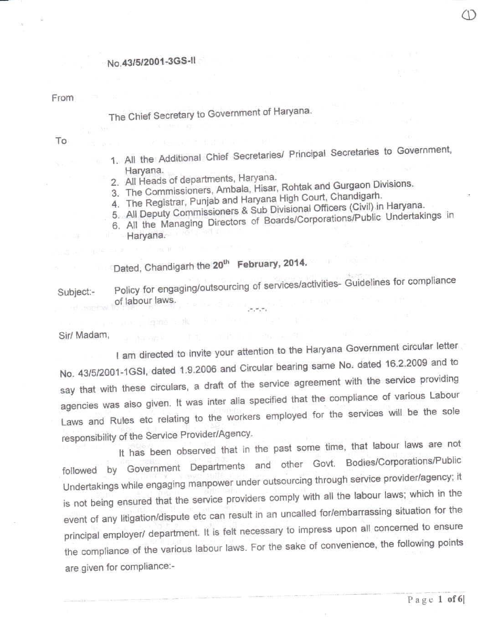
ANNEXURE - I
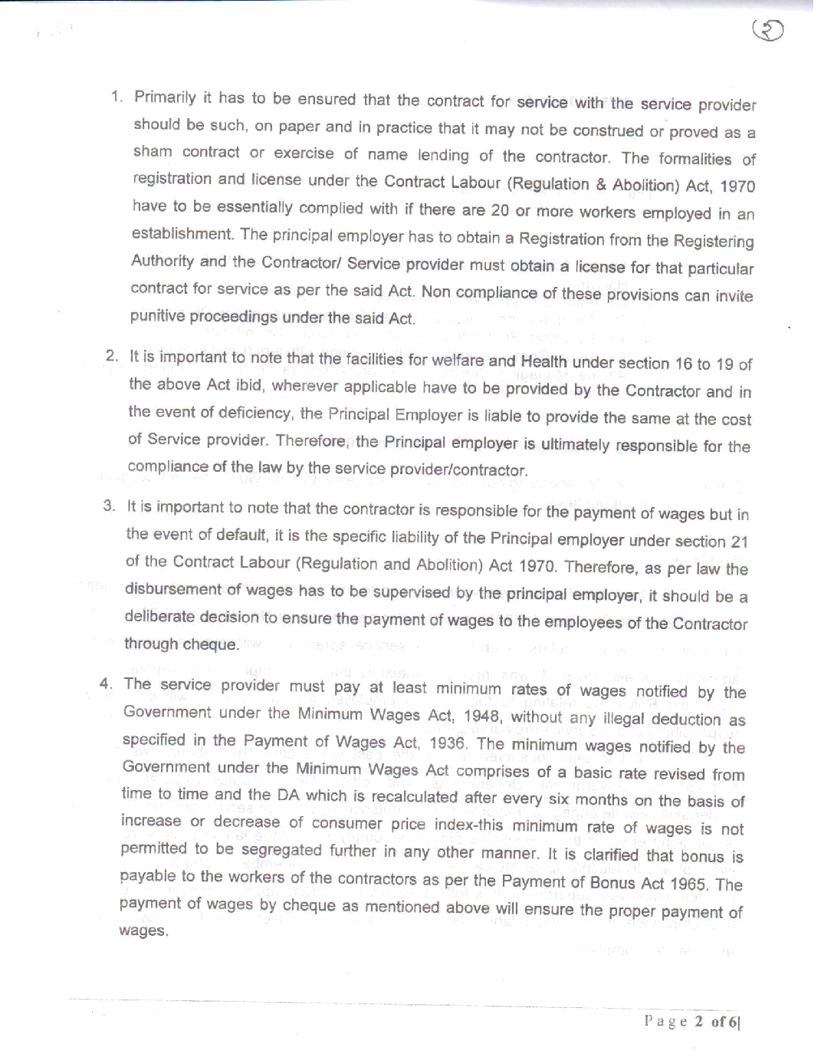
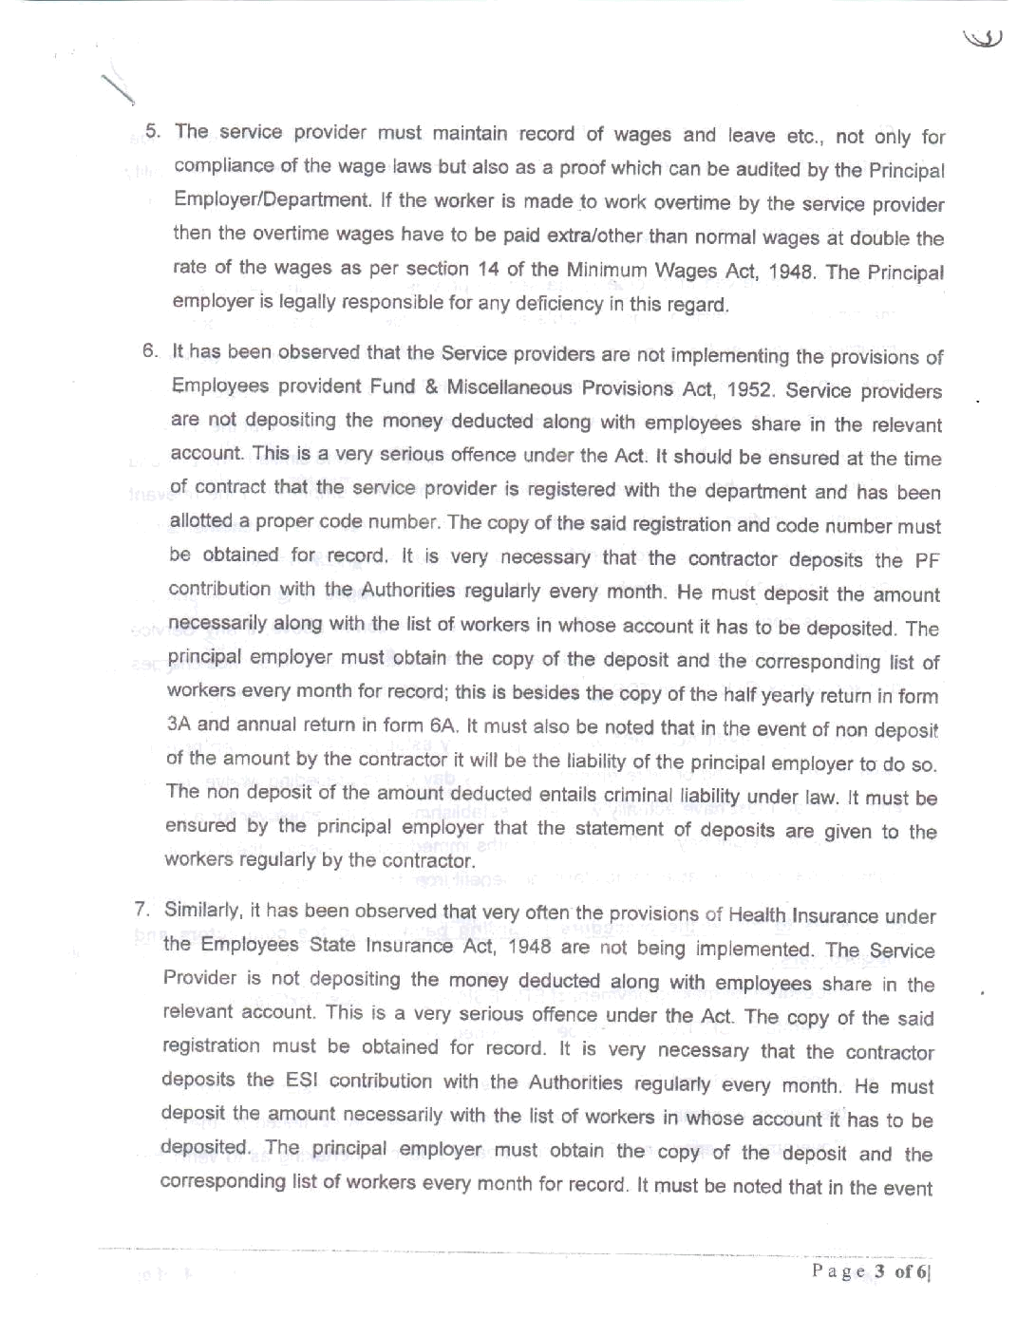
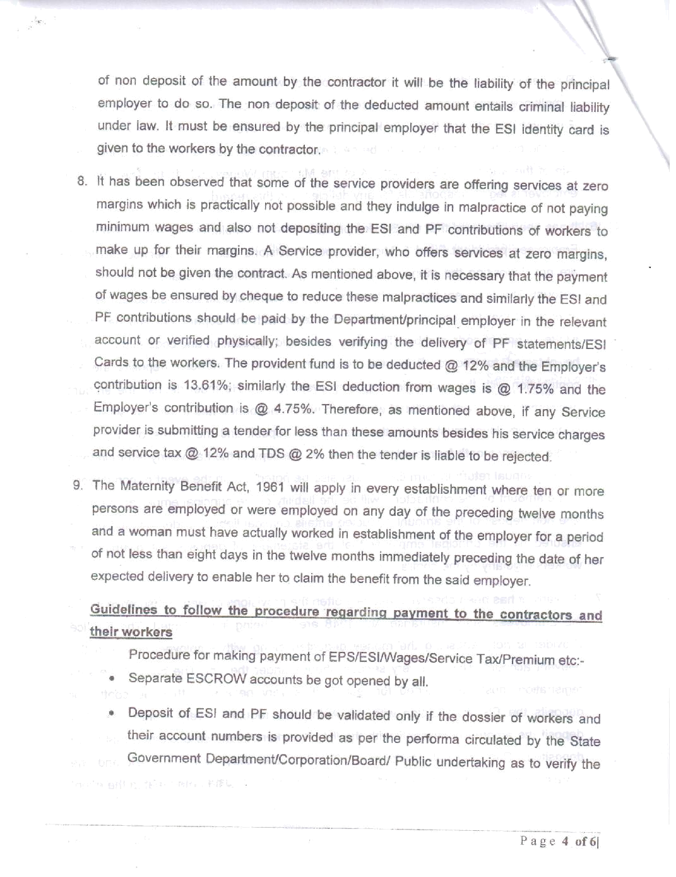

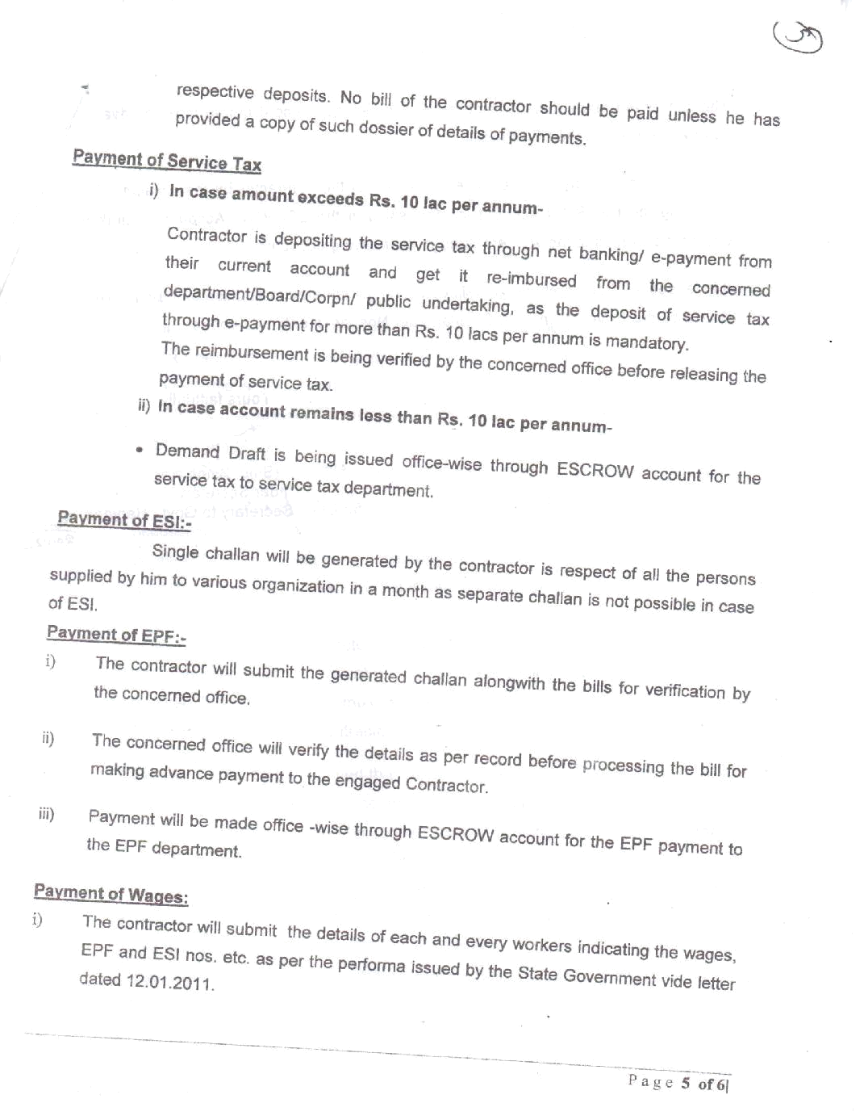
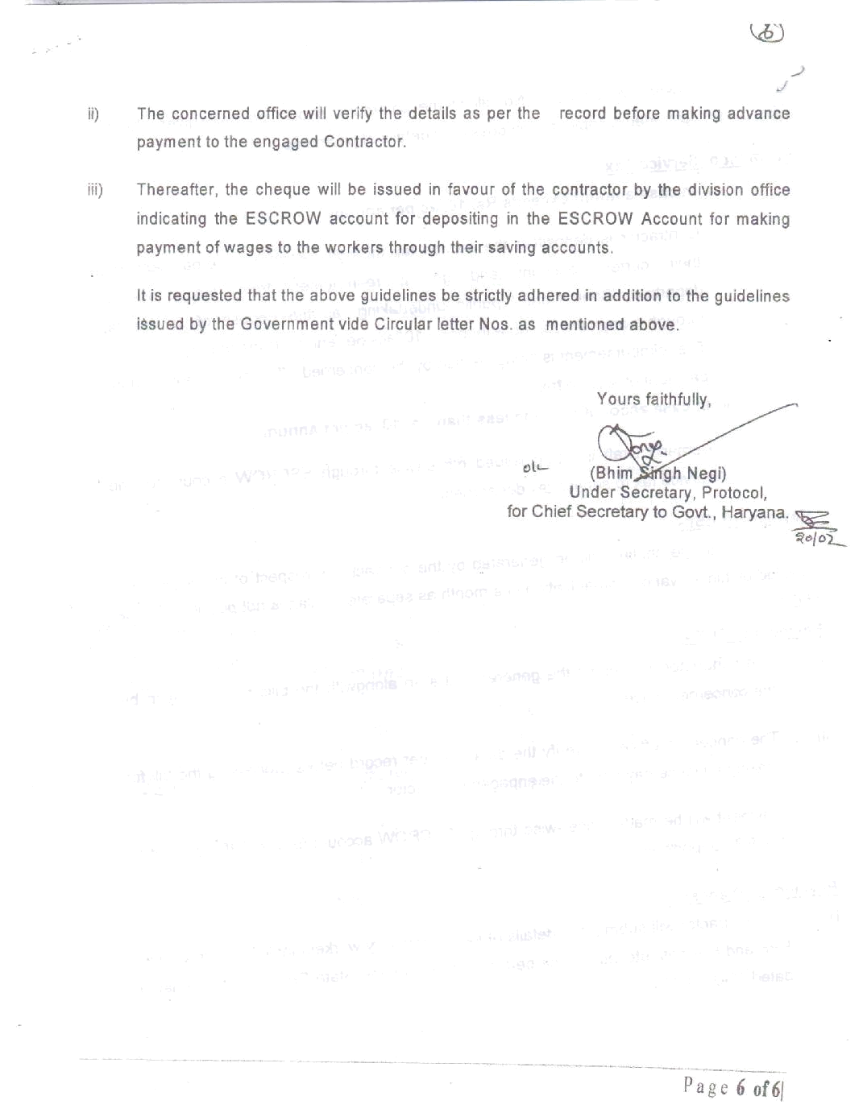
ANNEXURE-II
Format for Joint Venture Agreement
(on non-judicial stamp paper of appropriate value to be purchased in the name of executants companies or as required by the jurisdiction in which executed)

This Joint Venture Agreement executed on this...................day of....................... Two Thousand.................................By:
M/s. ......................................................... a Company/Partnership Firm/ Sole Proprietorship Organisation incorporated under the Act/Laws of ................................................................and having its Registered/Head Office at......................................(hereinafter called the “Lead Member/First Member” which expression shall include its successors); and M/s. ........................................................... a Company/Partnership Firm/Sole Proprietorship Organisation incorporated under the Act/Laws of ......................................................................................................and having its Registered/Head office at.................................... (hereinafter called the “Second Member” which expression shall include it successors).
The Lead Member/First Member and the Second Member shall collectively hereinafter be called as the “Joint Venture” for the purpose of submitting a bid proposal to Maharshi Dayanand University, Rohtak (Hereinafter referred to as MDU), being,,,,,,,,,,,,,,,,,,,,,,,,,,,,,,,,,,,,,,,,,,,,, (hereinafter called the “Owner”) in response to the invitation of bids (hereinafter called as “Tender No...................” Document) Dated............................ for Providing the services of Secretarial Staff for offices, Laboratories, Library etc. in the University.

WHEREAS Two or more bidder(s) may from a joint venture among themselves and apply against this tender specification, provided they fulfill the following eligible criteria;
- They should have legally valid Joint Venture agreement as per the prescribed format for the purpose of participation in the bidding process. The total no. of a Joint Venture shall be limited to two members.
- One of the Joint Venture member should be manpower supply company/ agency having registered with..........................................
- Joint Venture as a whole shall meet the qualifying norms specified in the tender, they participate.
- The Joint Venture member(s) shall authorize the lead partner by submitting a power of Attorney as per the prescribed format duly signed by the authorized signatories. The lead partner shall be authorized to receive instructions for and on behalf of partners of the Joint Venture and entire execution of the contract.
- The Joint Venture and its members shall be jointly and severally responsible and be held liable for the purpose of guaranteed obligation and any other matter as required under the contract.
- Any member of the Joint Venture shall not be eligible either in an individual capacity or part of any other Joint Venture to participate in the tender, where the said Joint Venture participates.
- Work Order(s) will be placed to lead members of the Joint Venture.
- In addition to the above the Lead Partner of the bidder(s) should submit the following documents in part-I bid as qualifying terms.
i. Registration Certificate with any State/Central Govt. agency.
ii. PAN & GST No.
iii. EPF registration, ESI registration
- The Lead partner of the Bidder(s) shall have to furnish service EPF registration, ESI registration in Rohtak and Labour license within 45 days of receipt of the order.
- The prescribed formats for Power of Attorney (Annexure-III) is provided in the tender specification as enclosures.

AND WHEREAS the members of the Joint Venture together shall strictly comply the eligible criteria of the Invitation for Bids (IFB).

AND WHEREAS bid has been proposed to be submitted to the Maharshi Dayanand University by Lead member based on this Joint Venture agreement between the members, signed by all the members.

NOW THIS INDENTURE WITNESSETH AS UNDER:
In consideration of the above premises, in the event of the selection of Joint Venture as successful bidder, all the Parties to this Joint Venture Agreement do hereby agree abide themselves as follows:

- M/s. ...................................... shall act as Lead Member for and on behalf of Joint Venture. The said Joint Venture further declare and confirm that they shall jointly and severally be bound and shall be fully responsible to the Owner for Providing the services of Secretarial Staff for offices, Laboratories, Library etc. in the M.D.University, Rohtak as per the Scope of Work, and successful performance of the works, obligations under the same by the Lead Member are as follows:
- Despite any breach by the Lead Member or other Member(s) of the Joint Venture the Member(s) do hereby agree and undertake to ensure full and effectual and successful performance of the Contract with the Maharshi Dayanand University and to carry out all the obligations and responsibilities under the said Contract in accordance with the requirements of the Contract.

- If the Maharshi Dayanand University suffers any loss or damage on account of any breach of the Contract or any shortfall in the performance in meeting the performance guaranteed as per the specification in terms of the Contract, the Member(s) of these presents undertake to promptly make good such loss or damages caused to the Maharshi Dayanand University, on its demand without any demur. It shall not be necessary or obligatory for the Maharshi Dayanand University to proceed against Lead Member to these presents before proceeding against or dealing with the other Member(s). The obligation of each of the member is absolute and not independent of the Joint Venture or any member.
- The financial liability of the members of this Joint Venture agreement to the Maharshi Dayanand University with respect to any of the claims arising out of the performance or non- performance of the obligations set forth in the said Joint Venture agreement, read in conjunction with the relevant conditions of the Contract shall, however, not be limited in any way so as to restrict or limit the liabilities of any of the members of the Joint Venture agreement. The liability of each member is absolute and not severable.
- It is expressly understood and agreed between the Members to this Joint Venture agreement that the responsibilities inter se amongst the Members shall not in any way be a limitation of joint and several responsibilities and liabilities of the Members to the Maharshi Dayanand University. It is clearly understood that the Lead member shall ensure performance under the agreements and if the Joint Venture fail to perform its /their respective obligations under the agreement(s), the same shall be deemed to be a default by all the Joint Venture Members. It will be open for the Owner to take any steps, punitive and corrective action including the termination of contract in case of such default also.
- This Joint Venture agreement shall be construed and interpreted in accordance with the laws of India and shall be subjected to exclusive jurisdiction within Rohtak in all matters arising there under.
- In case of an award of a Contract, all the Members to the Joint Venture agreement do hereby agree that Lead Partner shall furnish Performance Bank Guarantee for value of 5% of the Contract Price and additional 1% by the other Joint Venture Partner in the form of an unconditional irrecoverable Bank guarantee in the prescribed format and as per terms of the contract.
- It is further agreed that the Joint Venture agreement shall be irrevocable and shall form an integral part of the Contract, and shall continue to be enforceable till the Owner discharges the same. It shall be effective from the date first mentioned above for all purposes and intents.
- Capitalized terms used but not defined herein shall have the meaning as assigned to them in the Tender Documents and/or the agreements.
- In case of any dispute amongst the members of the Joint Venture Maharshi Dayanand University shall not be in any way liable and also the Joint Venture members shall not be absolved from the contractual obligation in any manner.

IN WITNESS WHEREOF the Members to the Joint Venture agreement have through their authorized representatives executed these presents and affixed Common Seals of their companies, on the day, month and year first mentioned above.

1. Common Seal of <……………..> For Lead/First Member
has been affixed in my/our presence
Pursuant to the Board of Director's (Signature of authorized
resolution/Proprietor dated.………. representative)

Name... …………….…………….
Signature.. ………….……………. Designation ..……….…………….
Name …………….…………….… Common Seal of the company
Designation…………….…………….…. ……….…………….…………….

2. Common Seal of <……………..>.,.,.,.,., For Second Member
has been affixed in my/our presence
Pursuant to the Board of Director's (Signature of authorized
resolution/Proprietor dated.………. representative)
Name... …………….…………….
Signature.. ………….……………. Designation ..…….…………….
Name ……………..………….… Common Seal of the company
Designation…………….…………….…. ……….…………….…………….

WITNESSES :

1……………………………… 2…………………………
(Signature) (Signature)
Name …………..……………. Name …………….…………….…
(Official address) (Official address)
(Annexure-III)

FORM OF POWER OF ATTORNEY FOR Joint Venture
(On Non –Judicial Stamp Paper of Appropriate value
to be Purchased in the Name of Joint Venture)

KNOW ALL MEN BY THESE PRESENTS THAT WE, the Members whose details are given hereunder…………………………….. have formed a Joint Venture and having our Registered Office (s)/Head Office (s) at ……………………………….(hereinafter called the ‘Joint Venture’ which expression shall unless repugnant to the context or meaning thereof, include its successors, administrators and assigns) do hereby constitute, nominate and appoint M/s……………………………………………. incorporated under the Registration No. .................................and having its Registered/Head Office at …………….as our duly constituted lawful Attorney ( hereinafter called “Lead Member ”) to exercise all or any of the powers for and on behalf of the JOINT VENTURE in regard to bid document No…………….. for various works……………………………………………………… for which bids have been invited by the Owner namely (Maharshi Dayanand University, Rohtak), to undertake the following acts :
- To submit proposal, participate and negotiate in respect of the aforesaid Bid – Specification of the Owner on behalf of the “Joint Venture”.

- To negotiate with Owner the terms and conditions for award of the contract pursuant to the aforesaid Bid and to sign the contract with the Owner for and on behalf of the “Joint Venture”.

- To do any other act or submit any document related to the above.

- To receive, accept and execute the contract for and on behalf of the “Joint Venture”.

- To submit the contract performance security in the form of an unconditional irrecoverable Bank guarantee in the prescribed format and as per terms of the contract.

It is clearly understood that the Lead Member shall ensure performance of the contracts (s) and if one or more Member fail to perform their respective portion of the contracts (s), the same shall be deemed to be a default by all the Members.

It is expressly understood that this power of Attorney shall remain valid binding and irrevocable till completion of the Defect or liability period in terms of the contract.

The Joint Venture hereby agrees and undertakes to ratify and confirm all the whatsoever the said Lead Member quotes in the bid, negotiates and signs the Contract with the Owner and / or proposes to act on behalf of the Joint Venture by virtue of this Power of Attorney and the same shall bind the Joint Venture as if done by itself.

IN WITNESS THEREOF the Members Constituting the Joint Venture as aforesaid have executed these presents on this ………… day of …….. under the Common Seal (s) of their Companies

for and on behalf of
the Members of Joint Venture
1. ……………….………
2. ………………………

The Common Seal of the above Members of the Joint Venture :

The Common Seal has been affixed there unto in the presence of :

WITNESS

- Signature ……………………………………
Name ……………………………………….

Designation …………………………………

Occupation …………………………………

- Signature …………………………………...

Name ……………………………………….

Designation …………………………………

Occupation …………………………………

